INF 551

Midterm Report

Tong Wu

March 25, 2019

Midterm Report

During this period, I gather the data of videos I have been watching and the style of clothes I have been wearing every day and try to analysis my pattern from graphs.

I use JSON file to record my data and store them into firebase online system. After that, I could use Pandas to plot the relationship between date and daily watched video time. This could not only give us a chance to see how many minutes or hours I spend on video which could reflect my lifestyle and give me the feedback whether I should change my time schedule or not. Additionally, this JSON file also records my cloth data. I thought I could use supervised machine learning for prediction of my cloth-shoes pairs; however, my dataset is to small which will not be enough for me to train a model.

After this week, I will start to learn and use swift to design my user interface which might be a little challenge for me. Therefore, my plan B is to create a website to show my result and maybe add another feature which including sentiment analysis. Swift could be a hard thing to learn, however, I would love to use online sources and ask other people for help. By doing this, I could solve my problem.

I think I am pretty much on track and if I could continue my work, this project will be both fun and useful.

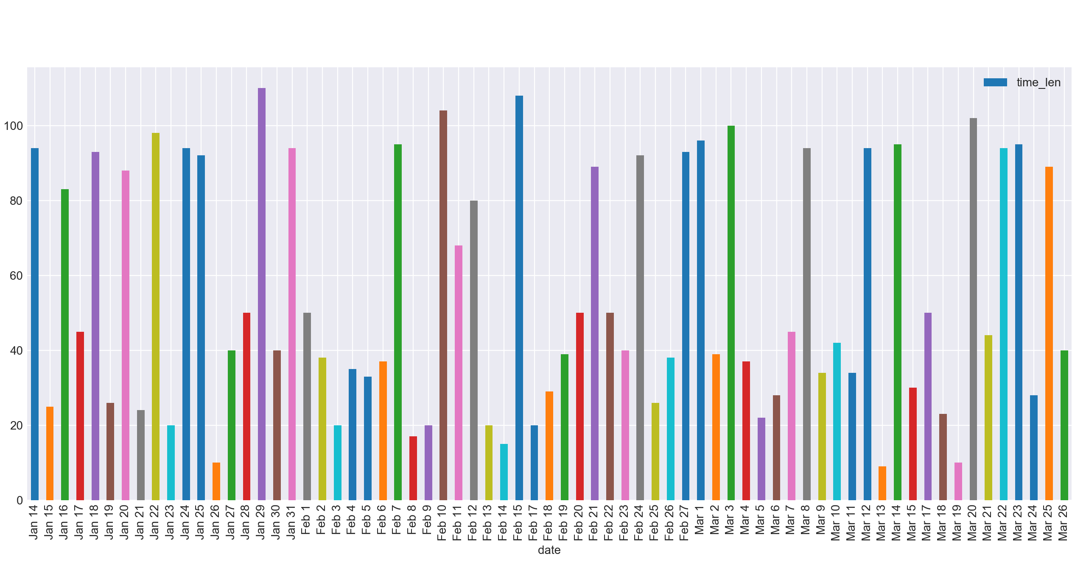Figure 1. Date vs Watching Time

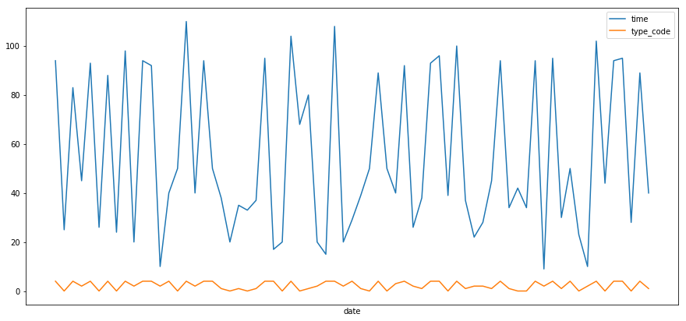Figure 2. Line Chart

Figure 3.

